Scouting for Food Collection
Saturday, April 26, 2014
Pack Contact: Joel Hurwitz, 651-269-0059
Drop Off: Emanuel Lutheran Church lower entry (70th & Babcock)
Assigned area map is on the other side of this sheet. Review beforehand in case you have any questions.
Door hangers to hang up days prior to that Saturday will be available from Pack Contact at least one week prior. If you are given donations while putting out door hangers, please note the address so as not to solicit the same house twice.
Meet up at 9:00 AM at Red Pine Elementary to check in. Bring grocery bags and boxes to collect donations. Boxes such as the sturdy handled Cub Food grocery boxes would be much appreciated. Wagons can also be helpful. Troop 455 will go over safety and expectations. Our combined goal is 2 TON!
Smile and look your best in uniform. Remember to not hit up any house twice and to be very appreciative of every person. Keep in mind some may not be able to donate today, the good impression you make will encourage their generosity in the future.
Bring donations to the drop off location. They will be handling weighing and sorting the donations for the food shelf.
Report hours worked by scouts and family members to p455.redpine@gmail.com along with a list of scouts and others participating from your den/patrol. Reporting volunteer hours is part of our Quality Unit Award (now called Journey to Excellence) requirements.
THANK YOU!

Scouting for Food Map
Pack 455
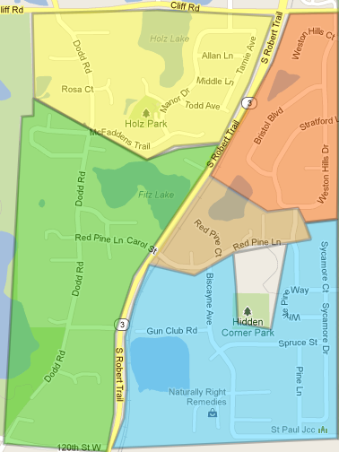
Tigers
Lions
Webelos
Bear Scouts
Red Pine
Wolf Scouts
Approximate number of homes per assigned area:
40 in Lion, 125 in Tiger, 150 in Wolf, 175 Bear, 120 in Webelos

