Group Activity: Computers
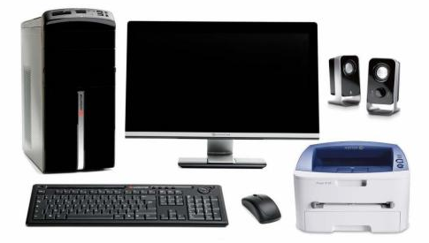
1: Draw a line to the parts of the computer
Central Processing Unit
Monitor
Keyboard
Mouse
Printer
Speakers
2: Find 10 devices that use computer chips to function
3: Use a spreadsheet program to write and organize information

Group Activity – Cameras
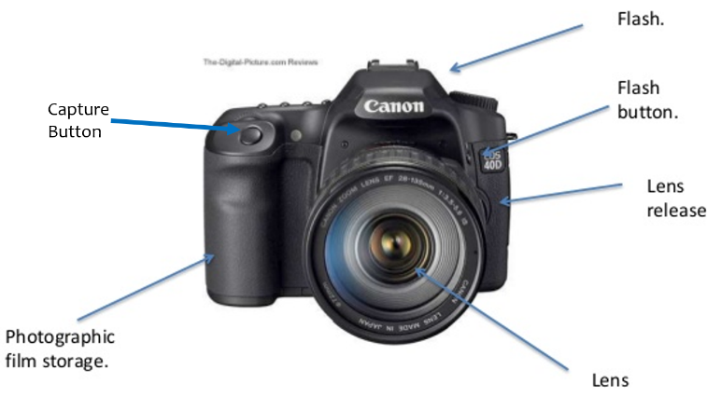
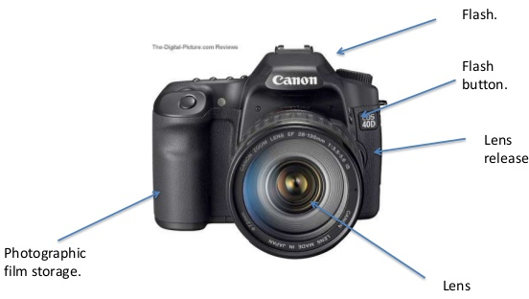
1: Identify what each part of the camera does
2: What does photography provide to modern life?
________________________________
________________________________
________________________________
3: Take 10 pictures to share at our next meeting

Learning Adventure
What is Technology
__________________________________________________________
__________________________________________________________
__________________________________________________________
How is Technology Used in:
Communication:
__________________________________________________________
__________________________________________________________
Business:
__________________________________________________________
__________________________________________________________
Construction:
__________________________________________________________
__________________________________________________________
Sports:
__________________________________________________________
__________________________________________________________
Entertainment:
__________________________________________________________
__________________________________________________________

