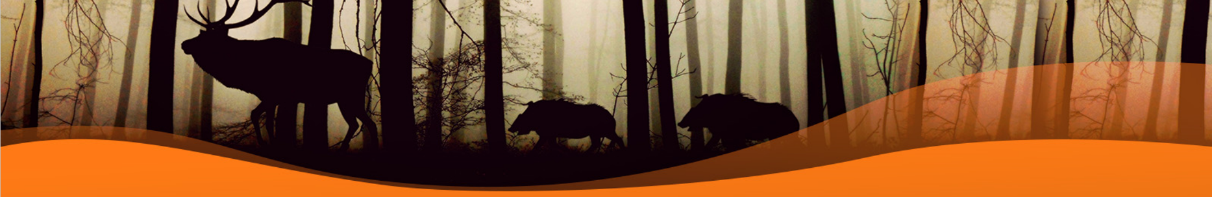
Group Activity – Water and Weather
The Water Cycle

Tracking the Weather
 | Measured | Actual
Day 1
Day 2
Day 3
Day 4
Day 5
Day 6
Day 7

Group Activity – Natural Resources

Natural resources are __________________________________
____________________________________________________
____________________________________________________
We need to protect them by ____________________________
____________________________________________________
____________________________________________________
The Food Chain

I read about an endangered species
____________________________________________________
____________________________________________________
____________________________________________________
Explore Wildlife
Wildlife is ___________________________________________
____________________________________________________
____________________________________________________

Tell me about:
Producers | Consumers | Prey | Predator

The Local Food Web

Act Like a Naturalist – Endangered Species

This is a _________________
________________________

It lives __________________
________________________

It is endangered because of
____________________________________________________
____________________________________________________
____________________________________________________

We can help it by _____________________________________
____________________________________________________
____________________________________________________
____________________________________________________

Act Like a Naturalist – Invasive Species

This is a _________________
________________________

It invades by______________
________________________

It damages the environment by
____________________________________________________
____________________________________________________
____________________________________________________

We can help contain it by _______________________________
____________________________________________________
____________________________________________________
____________________________________________________
`

Act Like a Naturalist – Visit an Ecosystem

Producers (P) – Herbavores (H) – Carnivores (C) – Omnivores (O)
Act Like a Naturalist – Minnesota Species

This habitat is for _____________________________________
____________________________________________________
____________________________________________________

It lives ______________________________________________
____________________________________________________
____________________________________________________

It eats ______________________________________________
____________________________________________________
____________________________________________________

It survives the winter by ________________________________
____________________________________________________
____________________________________________________
____________________________________________________

Act Like a Naturalist – Wild Neighbors

Day | Added Food | Added Water | Saw Visitor
1 | Yes / No | Yes / No
2 | Yes / No | Yes / No
3 | Yes / No | Yes / No
4 | Yes / No | Yes / No
5 | Yes / No | Yes / No
6 | Yes / No | Yes / No
7 | Yes / No | Yes / No
8 | Yes / No | Yes / No
9 | Yes / No | Yes / No
10 | Yes / No | Yes / No
11 | Yes / No | Yes / No
12 | Yes / No | Yes / No
13 | Yes / No | Yes / No
14 | Yes / No | Yes / No
15 | Yes / No | Yes / No
16 | Yes / No | Yes / No
17 | Yes / No | Yes / No
18 | Yes / No | Yes / No
19 | Yes / No | Yes / No
20 | Yes / No | Yes / No
21 | Yes / No | Yes / No

